**CARCD HIGH SCHOOL SPEAK-OFF COMPETITION**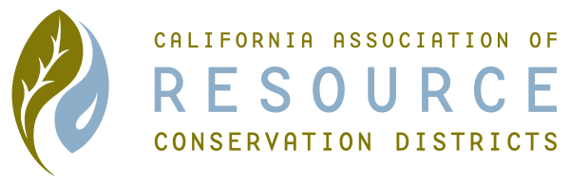

**2023 APPLICATION FORM**

**2023 Topic:**

**California climate is changing, and groundwater recharge will be important to ensure water for future generations. Are there other natural resource benefits to groundwater recharge projects and how can RCDs help? What local or regional examples can you point to and how have these examples helped your community?**

Name: ____________________________________________________________

Age: _____________________________________________________________

Address: __________________________________________________________

City/ Zip: __________________________________________________________

Phone: (_____) ____________________________________________________

High School: _______________________________________________________

Grade: ____________________________________________________________

Club Affiliations: _____________________________________________________

__________________________________________________________________

Briefly state your interest in conservation, environmental, or agricultural practices:

_____________________________________________________________________________________

_____________________________________________________________________________________

_____________________________________________________________________________________

______________________________________________________________________________________

Return to your local Resource Conservation District Office

RCDs Please Note:

E-mail your Regional Winner’s application to the CARCD office (taylor-stubblefield@carcd.org) by November 1st, 2023.

Please include regional name and regional speak-off oversight person’s name and phone number.

705 E Bidwell Street, Suite 2-415

Visit us at: <http://www.carcd.org>

E-mail us at: info@carcd.org